6A^{th} Grade: Unit 6, Lesson 6

- Two negative integer chips are shown.

Describe how you would evaluate -2 – 6 using integer chips.
6 positive chips need to be subtracted, so 6 zero pairs will need to be added to the model. After removing 6 positive integer chips, the difference is the remaining chips, which is -8.

- The integer chips shown are being used to find -5 – 1. What would be the next step?
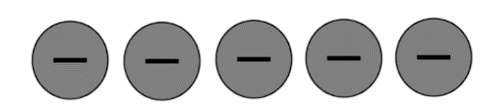

Subtract one positive chip.

- What type of number would result from the visual model shown?
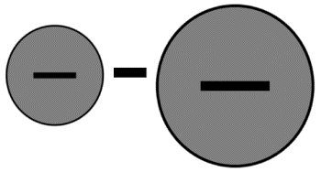
Positive

